Community Awareness Series: Promoting Healthy Behaviors

Schools, parents, caregivers and communities all play a role in providing supportive pathways for our youth as they navigate childhood and adolescence. SCIP (School Community Intervention and Prevention) is partnering with Lincoln Public Schools, Bryan Independence Center and the Lancaster Prevention Leadership Team to put on a series of valuable presentations about how to support the health and well-being of our community’s youth. Please join us on:
February 27, 2020- Youth Anxiety and Depression
Lincoln High School/Media Center
6:30 – 8:00 p.m.

Presentation:
Anxiety and depression continue to be two of the most common mental health issues that arise in today’s youth. Knowing how to recognize early warnings signs of anxiety and depression and how to support youth who may be struggling, are two important factors in early intervention. Melissa Tucci is licensed as an Independent Mental Health Practitioner and an Alcohol and Drug Counselor. She has worked in various settings with children, adolescents, and families experiencing trauma, out-of-home placement, reunification, and mental health and/or alcohol use problems. Melissa Tucci has been a SCIP provider since 2014. James Tucci is a Licensed Independent Mental Health Practitioner (LIMHP) in the state of Nebraska. James has worked in residential, acute care (hospital), in-home, day treatment, and outpatient settings. He has assisted children, adolescents, families, couples, and individuals with issues related to abuse and trauma, depression, anxiety, resolving problems and increasing skills, and optimizing parenting effectiveness. Together Melissa and James will discuss:

- What is anxiety and depression and how might it look in children and adolescents?
- Misconceptions about anxiety and depression
- Treatment of anxiety and depression: shifting from a "control strategies" approach to a values-based, committed action approach
- Effective, flexible parenting responses for parents of children and adolescents experiencing anxiety and/or depression.

Please contact Abbe Edgecombe, SCIP Coordinator for Lincoln-Lancaster County for questions or additional information: (402) 327-6841 or aedgecombe@lmep.com

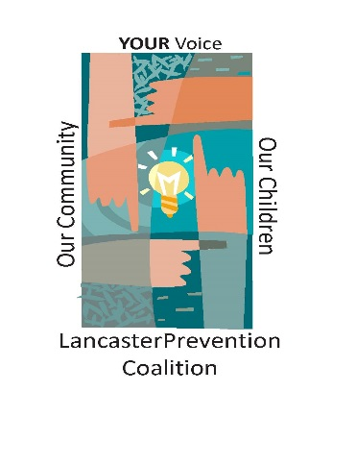
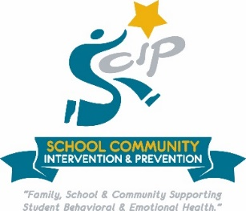
Bryan Independence Center

